EPC: Edge Position Controller

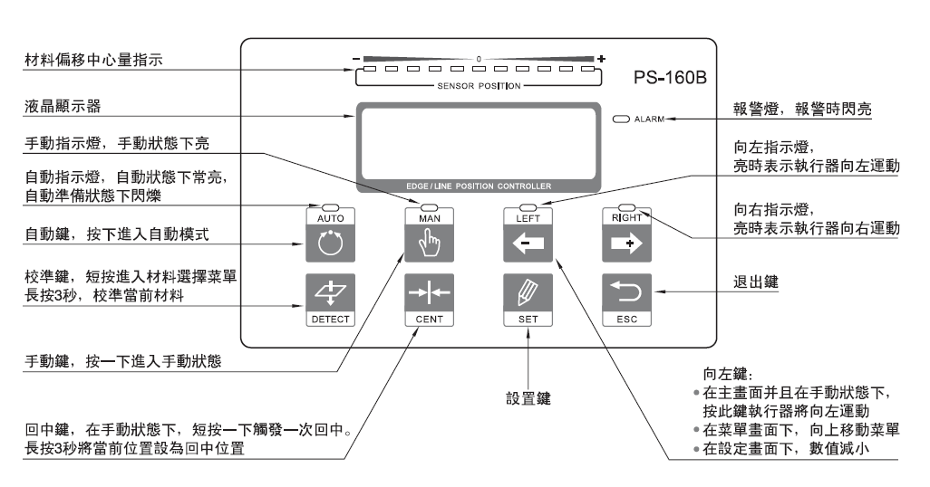

**AUTO:** automatic mode. Click it the EPC will detect the tape edge and track its position automatically.

**MAN:** manual operation mode. Click it to enable operate the EPC manually.

**LEFT:** in manual mode, click it the EPC will move the tape toward left side.

When checking EPC menu, click here to move the list up

When set the EPC, click here to decrease the value

**RIGHT:** in manual mode, click it the PEC will move the tape toward right side.

**DETECT:** detect the tape material. Short click to select the material list, Long press 3 seconds will make the EPC detect the current material.

**CENT:** make the EPC come to center position. Short click to make tape come to center position. Long press 3 seconds will fix the current position as the center.

**SET:** click to set parameters. Password is 810 or 818.

**ESC:** Back to last option.

Hot key combination:

**SET + LEFT or RIGHT:** in AUTO mode, adjust the value **P** of the EPC gain.

**ESC + LEFT or RIGHT:** in AUTO mode, adjust the value **I** of the EPC gain.

**AUTO + LEFT or RIGHT:** in AUTO mode, to convert the EPC moving direction

**LEFT + RIGHT for 3 seconds:** in MAN mode, to measure the EPC stroke automatically.

**Calibrating:** Only laser detect sensor needs to be calibrated, while the ultrasonic detect sensor does not need this option

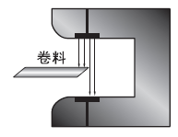 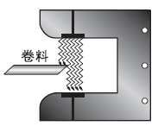

Laser sensor Ultrasonic sensor

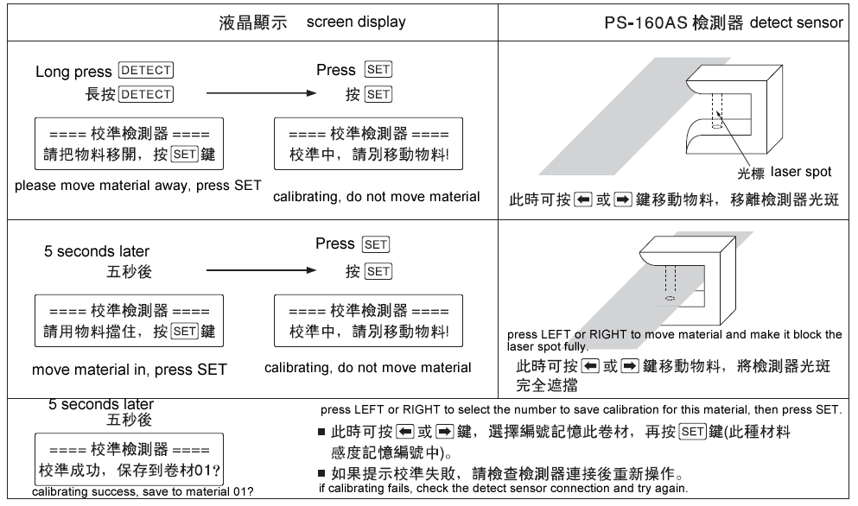

The controller saved 3 types of calibrating before delivered to customer: 01 for opaque material, 02 for semitransparent material, 03 for transparent material.

When the screen displays in home page, press DETECT to enter the selecting from saved calibrations. Press LEFT or RIGHT to select proper material number. Then press SET to confirm the select.

If there is no proper material calibrating saved in the controller, make a new calibrating and save it in the controller as above picture shows.